**Motion**

Circular Motion

Practise Book 1

Name: ________________

General Consolidation

Some Advanced Questions

Give all answers to 3sf

Ask me if you are stuck on any of these and there are answers provided, too.

1) Indoor cycling is carried out in a velodrome. A velodrome is a circular shaped track that banks at a certain angle for cyclists to move without falling off their bikes.

a) Explain the Physics behind the banking of the track?

**Ans: The banking provides Fc to move in circular motion from the horizontal component of Normal Force.**

The baking provides the centripetal force to move in circular motion from the horizontal component of the normal force.

b) If the radius of the track is 35m and the speed of the cyclist is 12.3 m/s determine the angle of banking?

**Ans: 23.8\***

tanθ = $\frac{{12.3}^{2}}{(9.8)(35)}$ = 0.441

θ = tan-10.441 = 23.8°

2) Determine to the vertical, how much a footballer of mass 80kg moving at 5.25 m/s with a radius of 25m must bank to complete the circle without falling over?

**Ans: 6.4\***

tanθ = $\frac{{5.25}^{2}}{(9.8)(25)}$ = 0.113

θ = tan-1(0.113) = 6.42°

3) A car with mass 1200 kg is being driven at 35m/s on a road which is banked at 15*. The car does not skid.

a) Draw a vector diagram for the above situation

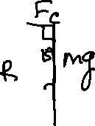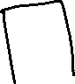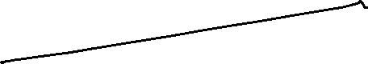

b) Calculate the total Fc needed by the car? **Ans: 2.45x104N**

c) Determine the amount of Fc supplied by the tires? **Ans: 3.15x103 N**

tan15 = → Fc = (1200)(9.8)tan15 = 3.15 x 103N

d) How much Fc is provided by friction? **Ans: 3.13x104N**

e) What is the slowest speed the car can safely travel around the bend? **Ans: 12.6 m/s**

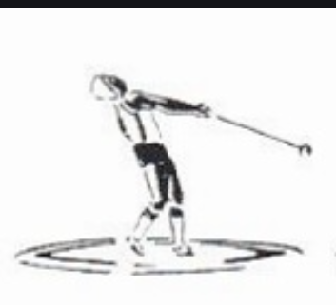4) A hammer thrower rotates a hammer of mass 6.5 kg around a horizontal circle. The radius of the circle is 1.75 m. Each complete swing of the hammer takes 0.815 seconds. The hammer is attached to a string such that the string makes an angle θ with the horizontal.

a) Determine the Net Force acting on the hammer? **676 N**

b) What is the magnitude of tension in the string? **679 N**

c) What is the value of θ? **5.38\***

5) Explain why it is impossible for a person to swing at 90* to the horizontal in a circular fashion?

**Hint: What is tan 90 =? And tan θ = v^2/rg**